**EE311 Assignment 3 Report – Barışcan Köse / 25413**

A,B,C)

This is my Simulink schematic with no path estimator. Note that the ANC(Acoustic Noise Cancellation) Updater’s input is coming directly from the Pink Noise. It quickly cancelled the noise. Channel is the to mimic the path the noise takes before it reaches our ears with the buffer in the headphone’s cushions and the air between and whatnot. ANC Filter is fed the weights/anti-noise coefficients that we get from the ANC Updater. Note the error port of ANC Update is fed the final sound to continuously update is weights in order to further attenuate the sound.

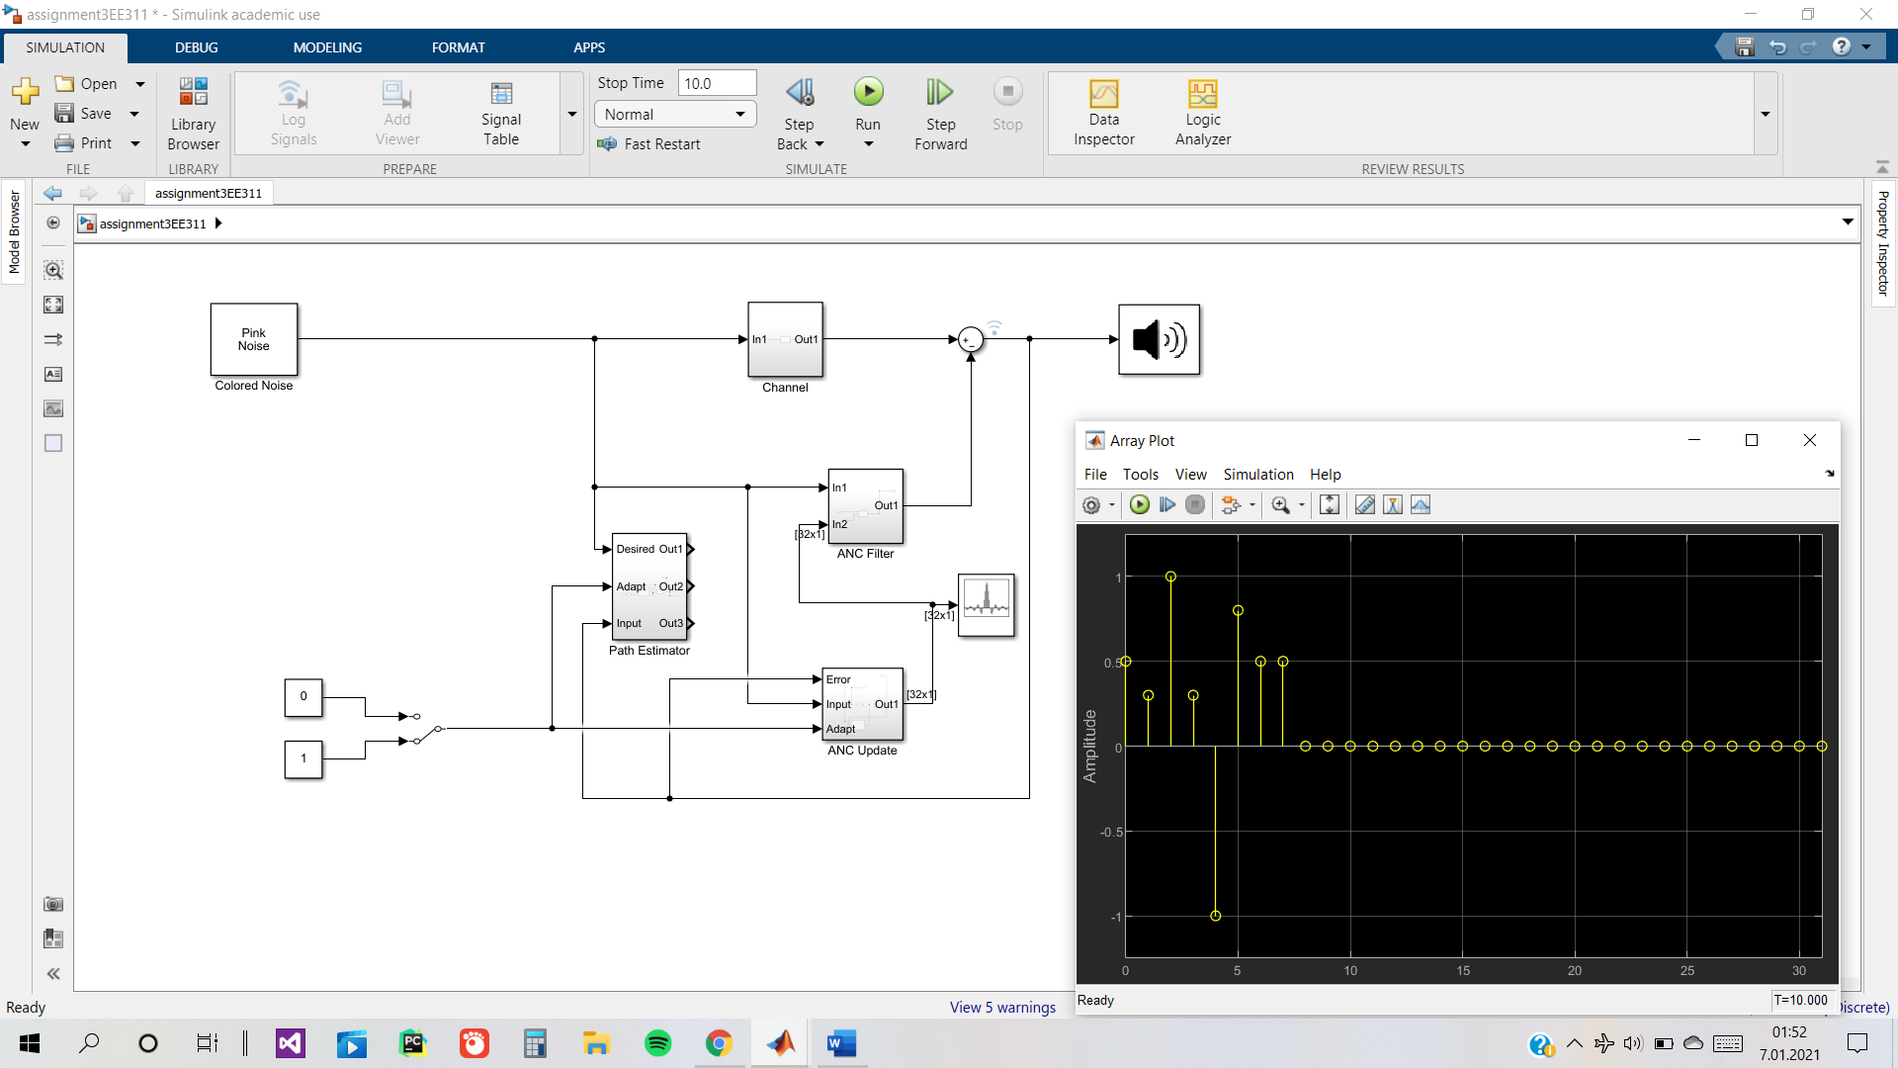

D)

In this case, the input port of the ANC Updater is fed the weights/coefficients the path estimator produces. This takes the path the sound takes ,from the external source finally to our ear, into account. It also worked pretty quickly with step size 0.05 and normalized LMS but it performs a little sluggishly when step size is too small or LMS is not normalized.

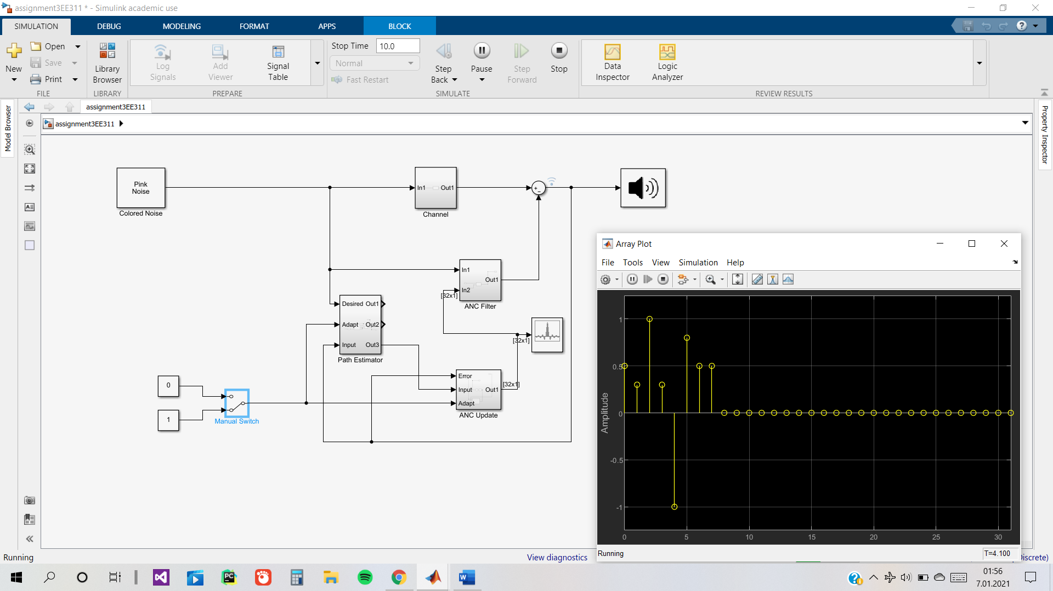

The Path Estimator 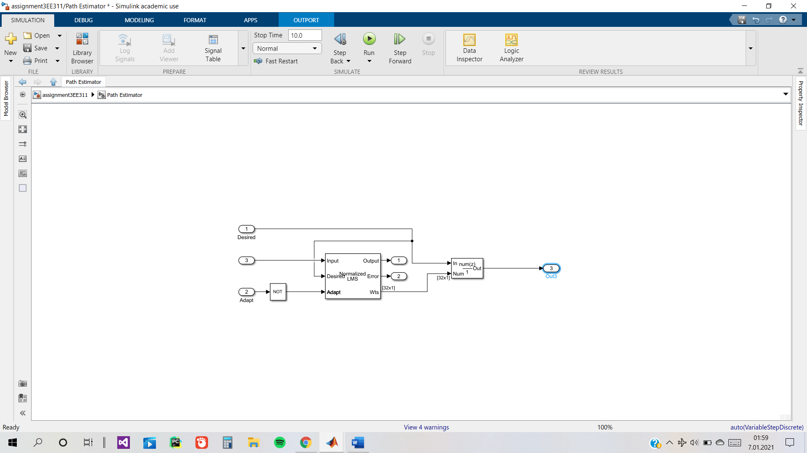

ANC Updater

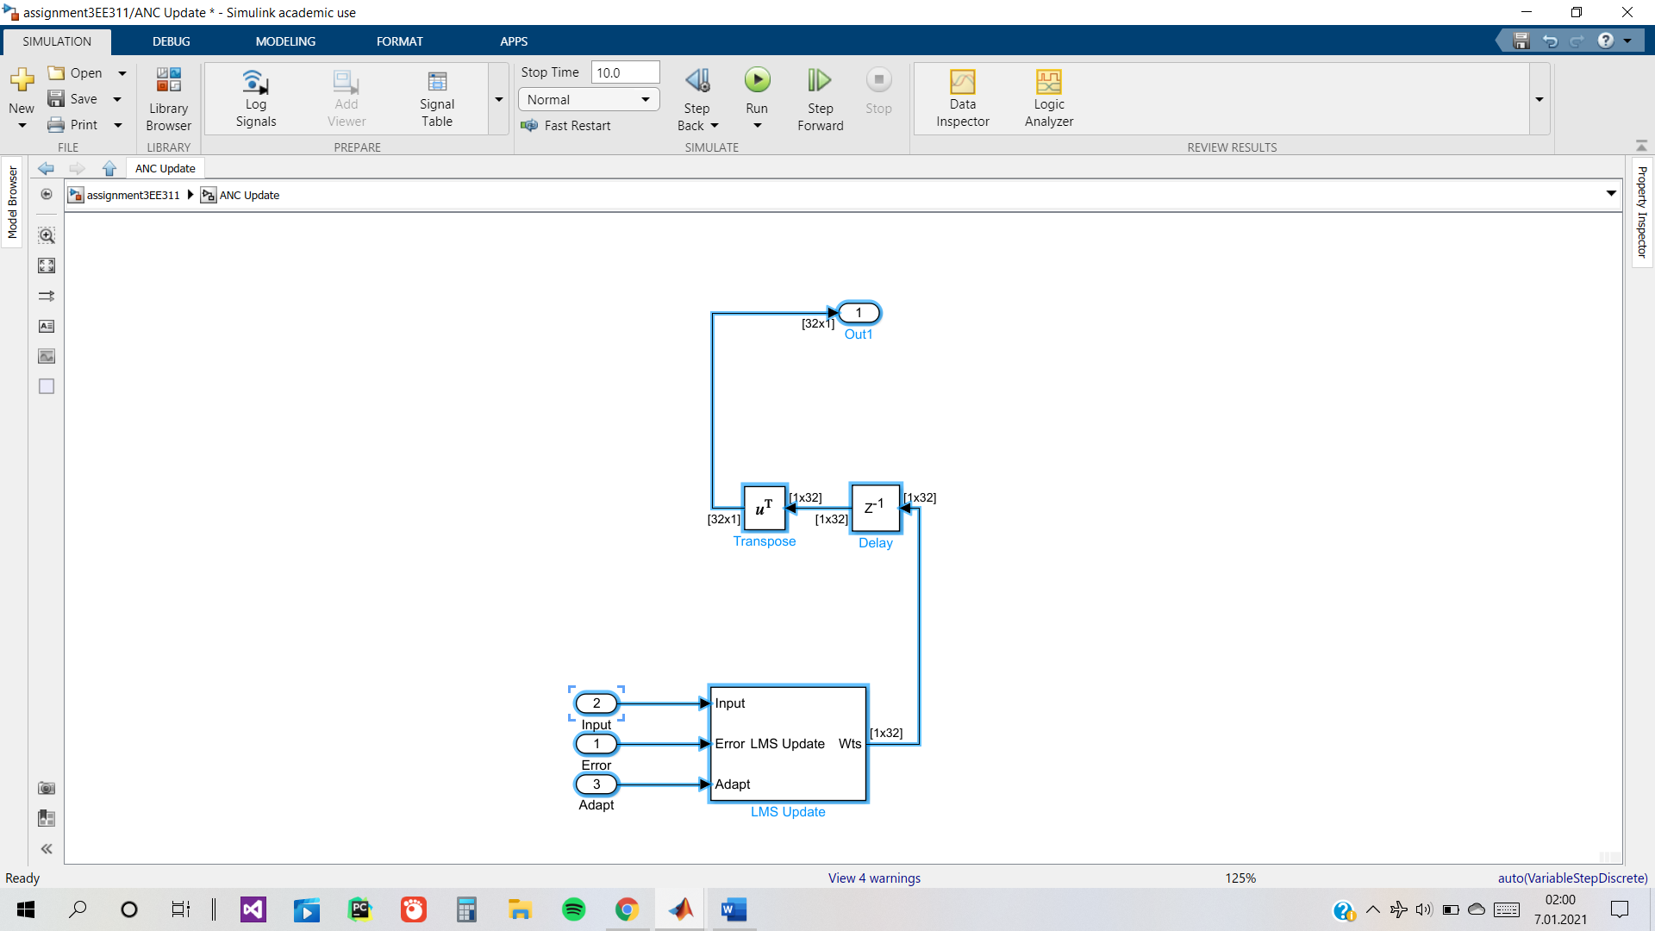

ANC Filter

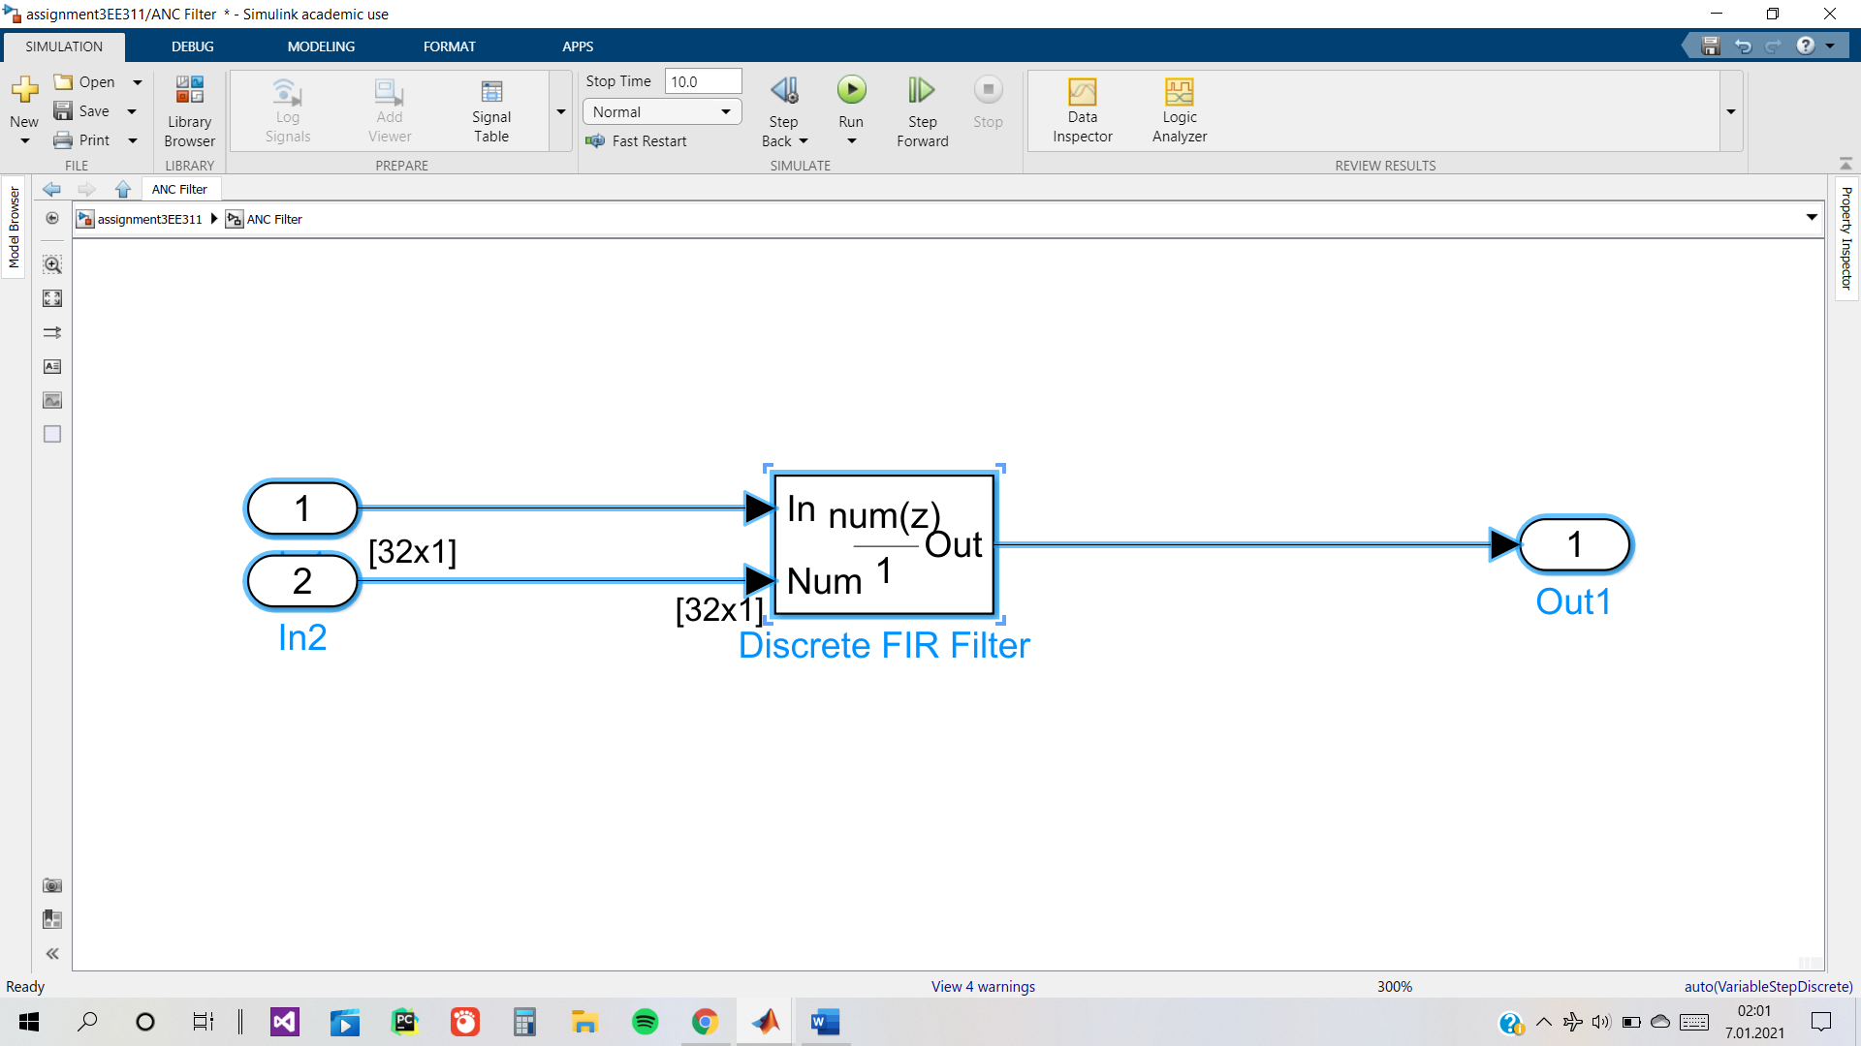

Channel

